**Screenshots:**

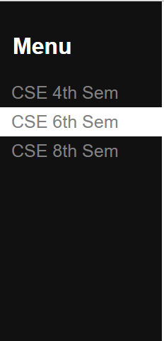 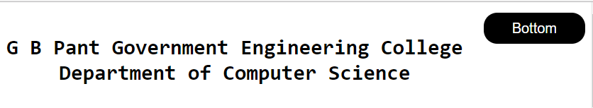

**Fig 4.1: Example of using <a> tag** **Fig 4.2: Example of button**

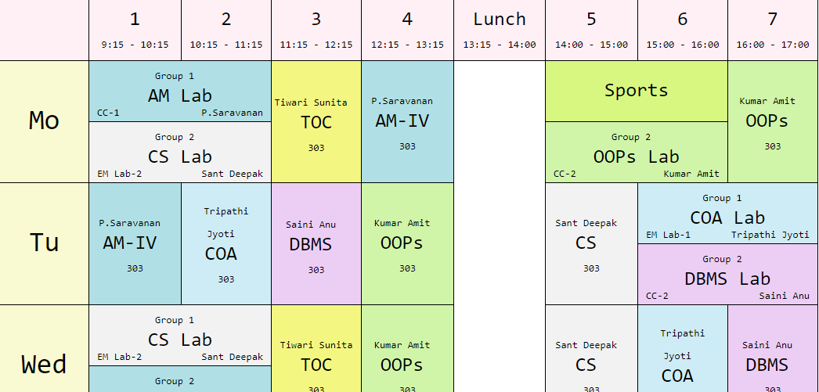

**Fig 4.3: Example of using table tag**

**Experiment – 04**

**AIM**: Create a layout for 3 Sem CSE time table in web document using inline styling and/or style tags.

**Basic Tags :**

* HTML**<!DOCTYPE>**Declaration: It is not an HTML tag. It is an instruction to the web browser about what version of HTML the page is written in.
* **<html>** Tag-The HTML document itself begins with <html> and ends with </html>.
* **<head>** Tag-HTML <head> tag is a Container Tag. All Header element contains like general information about page, meta-information, style sheet URL and document type information.
* **<body>** Tag-HTML body section is a main contain section of web page all contain that will be seen when the user loads the webpage.
* **<title>** Tag-The <title> tag is required in all HTML documents and it defines the title of the document.
* **<center>** Tag-It is used to center-align text.
* **<font>** Tag-It specifies the font face, font size, and color of text.
* **<b>** Tag-It specifies bold text.
* **<i>** Tag-Its content is displayed in italic.
* **<u>** Tag-It underlines the text.
* **<span>** Tag-It is used to group inline-elements in a document.
* **<i>** Tag-Its content is displayed in italic.
* **<u>** Tag-It underlines the text.
* **<br>** Tag-It is an empty tag which means that it has no end tag and it inserts a single line break.
* **<a> Tag-** It defines a hyperlink, which is used to link from one page to another.
* **<button> Tag-** The <button> tag defines a clickable button.
* **<table>** Tag-It is a tag element to define a table.
* **<caption>** Tag-It is a tag element to define a table caption

**Screenshots:**

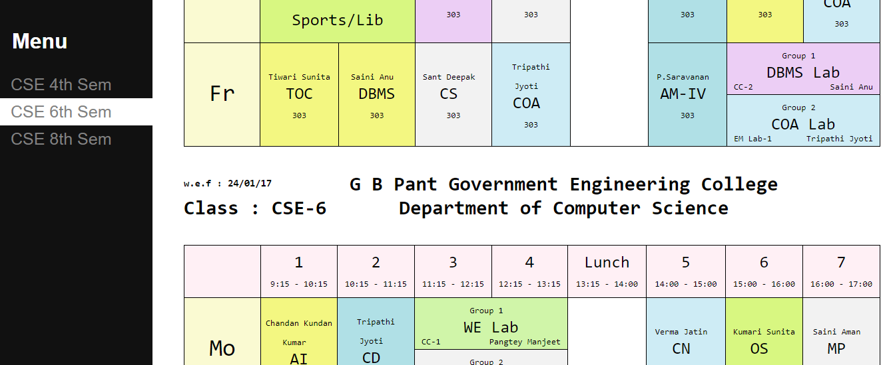

**Fig 4.4: Use of position:fixed on div**

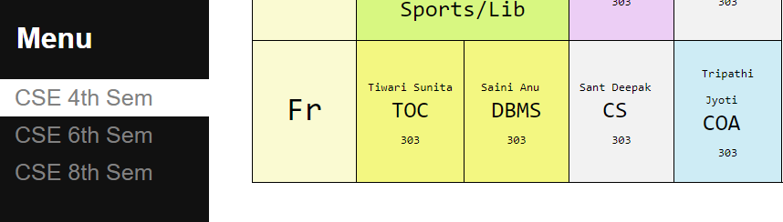

**Fig 4.5: Use of hover on <a> tag**

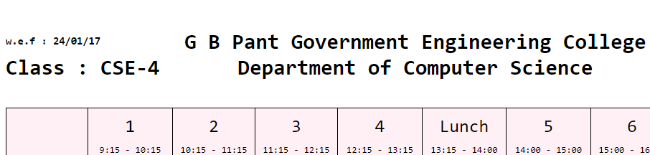

**Fig 4.6: Use of display:block tag**

**ATTRIBUTES**

* **Position:** The position property specifies the type of positioning method used for an element (static, relative, absolute, fixed, or sticky).

|  |  |
| --- | --- |
| **Value** | **Description** |
| static | Default value. Elements render in order, as they appear in the document flow. |
| absolute | The element is positioned relative to its first positioned (not static) ancestor element |
| fixed | The element is positioned relative to the browser window. |
| relative | The element is positioned based on the user's scroll position  A sticky element toggles between relative and fixed,  depending on the scroll position. |
| Initial | Sets this property to its default value. |
| inherit | Inherits this property from its parent element |

* **Hover:** The :hover selector is used to select elements when you mouse over them.
* **Display:** The display property specifies the display behavior of an element.

|  |  |
| --- | --- |
| **Value** | **Description** |
| inline | Default value. Displays an element as an inline element (like <span>). Any height and width properties will have no effect. |
| block | Displays an element as a block element (like <p>). It starts on a new line, and takes up the whole width. |
| flex | Displays an element as a block-level flex container. |
| inline-block | Displays an element as an inline-level block container. The element itself is formatted as an inline element, but you can apply height and width values. |

**Screenshot:**

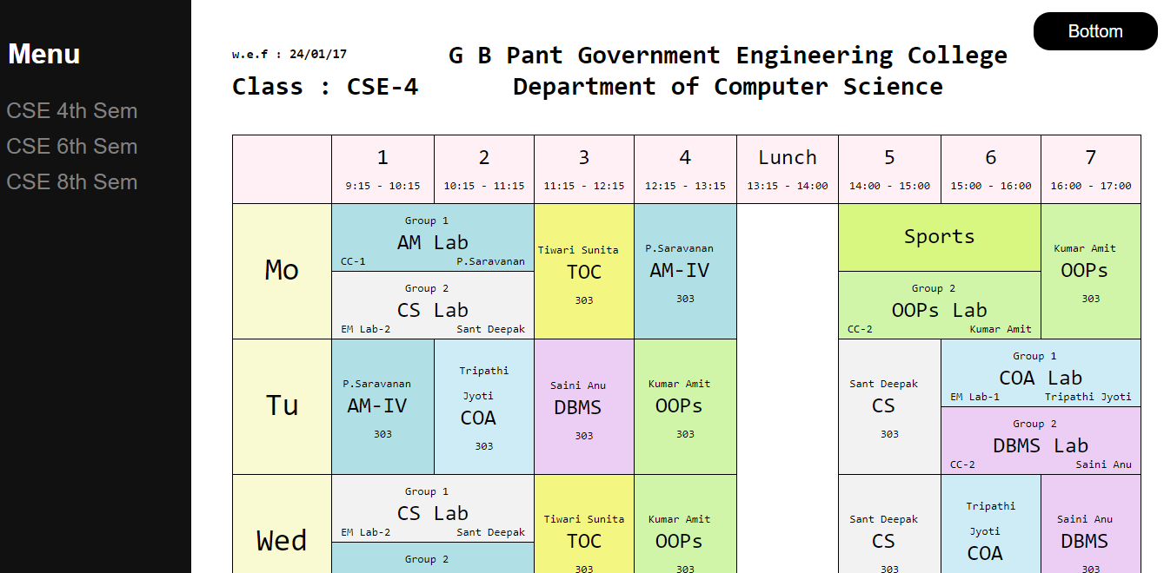

**Fig 4.7: Full view of the output page**

**Code snippets:**

**Code for side fixed menu :**

<div style="height: 100%;width: 17%;position: fixed; top: 0;left: 0; background-color: #111;padding- top: 20px;">

<h1 style="padding: 4px 18px; color:white">Menu</h1>

<a style=" padding: 6px 8px 6px 16px; text-decoration: none;font-size: 25px;color: #818181; display: block;"

href="#4th">CSE 4th Sem</a>

<a style=" padding: 6px 8px 6px 16px; text-decoration: none;font-size: 25px;color: #818181; display: block;"href="#6th">CSE 6th Sem</a>

<a style=" padding: 6px 8px 6px 16px; text-decoration: none;font-size: 25px;color: #818181; display: block;"href="#8th">CSE 8th Sem</a>

</div>

**Code for button:**

<div style="float: right"><a href="#8th" style="background-color: black;font-size: 20px;color: white;border-radius: 19px;text-decoration: none;padding: 11px 40px;">Bottom</a>

</div>

**Code for HTML Table with a table:**

<div style="width: 85%;float:right;">

<div id="4th">

<br>

<div style="float: right"><a href="#8th" style="background-color: black;font-size: 20px;color: white;border-radius: 19px;text-decoration: none;padding: 11px 40px;">Bottom</a></div>

<div style="width:88%;height:100%;margin:auto; background-color:white;font-family: monospace;font-size:15px;">

<div>

<div style="width:25%;float:left;">

<p style="margin-top: 28px;font-weight: bold;">w.e.f : 24/01/17

<p>

<h1 style="margin-top:-5px;">Class : CSE-4</h1>

</div>

<div style="display:inline-block;">

<center>

<h1 >G B Pant Government Engineering College<br>

Department of Computer Science

</h1>

</center>

</div>

</div>

<br>

<table style="border-collapse:collapse;font-size:25px;width: 105%;">

<tr style="background-color:#FFF0F5; ">

<td style="border:1px solid black; padding:10px; width:100px;">

<center></center>

</td>

<td style="border:1px solid black; padding:10px; width:100px;"> <center>1<br><span style="font-size:13px">9:15 - 10:15</span></center>

</td>

<td style="border:1px solid black; padding:10px; width:100px;">

<center>2<br><span style="font-size:13px">10:15 - 11:15</span></center>

</td>

<td style="border:1px solid black; padding:10px; width:100px;">

<center>3<br><span style="font-size:13px">11:15 - 12:15</span></center>

</td>

<td style="border:1px solid black; padding:10px; width:100px;">

<center>4<br><span style="font-size:13px">12:15 - 13:15</span></center>

</td>

<td style="border:1px solid black; padding:10px; width:100px;" >

<center>Lunch<br><span style="font-size:13px">13:15 - 14:00</span></center>

</td>

<td style="border:1px solid black; padding:10px; width:100px;">

<center>5<br><span style="font-size:13px">14:00 - 15:00</span></center>

</td>

<td style="border:1px solid black; padding:10px; width:100px;">

<center>6<br><span style="font-size:13px">15:00 - 16:00</span></center>

</td>

<td style="border:1px solid black; padding:10px; width:100px;">

<center>7<br><span style="font-size:13px">16:00 - 17:00

</span>

</center>

</td>

</tr>

<tr>

<td style="border:1px solid black;padding:0px 10px 4px 10px;background-color:#FAFAD2;font-size: 36px;" rowspan="2">

<center>Mo</center>

</td>

<td style="border:1px solid black; padding:0px 10px 4px 10px;background-color:#B0E0E6;" colspan="2">

<center>

<span style="font-size:13px">Group 1</span>

<br>AM Lab<br>

</center>

<span style="font-size:13px;float: left">CC-1</span>

<span style="font-size:13px;float: right;">P.Saravanan</span>

</td>

<td style="border:1px solid black;background-color:#F3F781;" rowspan="2">

<center>

<span style="font-size:13px">Tiwari Sunita</span>

<br>TOC<br>

<span style="font-size:13px">303</span>

</center>

</td>

</tr>

</table>